BI LOT

CASE STUDY

IPL PERFORMANCE ANALYSIS

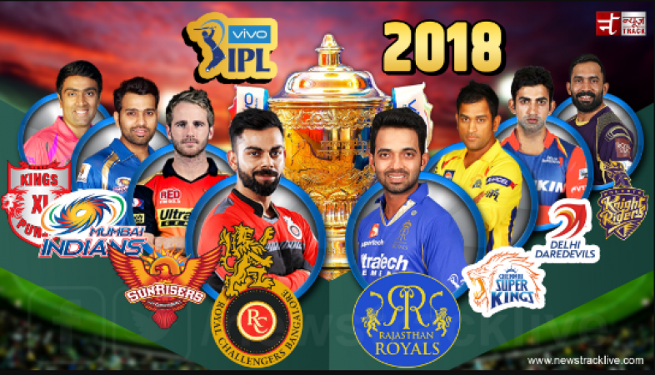

TABLE OF CONTENTS

|  |  |
| --- | --- |
|  | Introduction |
| 1.1 | Setup checklist for Case Study |
|  | Problem Statement |
| 2.1 | Objective |
| 2.2 | Abstract |
| 2.3 | Technology Used |
|  | Implementation |
| 3.1 | Summary of the functionality |
| 3.2 | Guidelines of the functionality |
| 3.3 | Schema Design |
| 3.4 | Data Model |

1. INTRODUCTION

This document outlines a case study. The case study is to develop IPL SEASON-WISE PERFORMANCE ANALYSIS.

This document contains the work flow of the system and gives guidelines on how to build the functionality gradually.

* 1. **Setup check list for case study**

Minimum System Requirements

* Intel Pentium 90 or higher (P166 recommended)
* Microsoft Windows 2010 or above.
* Memory: 4GB of RAM (4GB or more recommended)
* Internet Explorer 10.0 or higher
* Oracle 11G / SQL server 2012 or higher
* Informatica 10.2.0/SSIS/Data Stage/ Abinitio
* Tableau Desktop/SSRS/Power BI/ Qlikview

1. PROBLEM STATEMENT
   1. Objective

Development of **IPL SEASON-WISE PERFORMANCE ANALYSIS** to analyse following scenarios :-

* Which team won the highest number of matches season-wise?
* Percentage of winning matches after winning tosses?
* Percentage of winning a match when batting first?
* Top 3 stadium to host maximum number of matches in all seasons.
* Top 3 teams to win by maximum margin of runs season-wise?
* Umpires who umpired for maximum number of matches season-wise?
* Season-wise comparison of toss-decisions made?
* Win and Loss percentage of particular teams season-wise? (Any one team)
  1. Abstract

Cricket is a religion in India and people of all faiths, caste creed and language remain glued to the TV or the radio to watch international level matches. The Indian Premier League - IPL is a ‘20-20’ version of Cricket where professional club teams from different cities play about 80 games with a final game deciding the champion. IPL has acquired a social dimension and it can act as an instrument of change for other Indian sports.

The purpose of this project is to analyse the performance of each IPL season with respect to the different dimensions. It collects the data on various attributes like team performance, venues, seasons, winning and losing percentage, umpires in different seasons etc. There are 8 teams of IPL representing eight different cities in India. There have been twelve seasons of the IPL tournament. The current IPL title holders are the Mumbai Indians, who won the 2019 season.

| **Team** | | **City** | **Current captain** |
| --- | --- | --- | --- |
|  | [Chennai Super Kings](https://en.wikipedia.org/wiki/Chennai_Super_Kings) | [Chennai](https://en.wikipedia.org/wiki/Chennai), [Tamil Nadu](https://en.wikipedia.org/wiki/Tamil_Nadu) | [India](https://en.wikipedia.org/wiki/India) [MS Dhoni](https://en.wikipedia.org/wiki/MS_Dhoni) |
|  | [Delhi Capitals](https://en.wikipedia.org/wiki/Delhi_Capitals) | [Delhi](https://en.wikipedia.org/wiki/Delhi), [NCR](https://en.wikipedia.org/wiki/National_Capital_Region_(India)) | [India](https://en.wikipedia.org/wiki/India) [Shreyas Iyer](https://en.wikipedia.org/wiki/Shreyas_Iyer) |
|  | [Kings XI Punjab](https://en.wikipedia.org/wiki/Kings_XI_Punjab) | [Mohali](https://en.wikipedia.org/wiki/Mohali) ([Chandigarh](https://en.wikipedia.org/wiki/Chandigarh)), [Punjab](https://en.wikipedia.org/wiki/Punjab,_India) | [India](https://en.wikipedia.org/wiki/India)[Ravichandran Ashwin](https://en.wikipedia.org/wiki/Ravichandran_Ashwin) |
|  | [Kolkata Knight Riders](https://en.wikipedia.org/wiki/Kolkata_Knight_Riders) | [Kolkata](https://en.wikipedia.org/wiki/Kolkata), [West Bengal](https://en.wikipedia.org/wiki/West_Bengal) | [India](https://en.wikipedia.org/wiki/India) [Dinesh Karthik](https://en.wikipedia.org/wiki/Dinesh_Karthik) |
|  | [Mumbai Indians](https://en.wikipedia.org/wiki/Mumbai_Indians) | [Mumbai](https://en.wikipedia.org/wiki/Mumbai), [Maharashtra](https://en.wikipedia.org/wiki/Maharashtra) | [India](https://en.wikipedia.org/wiki/India) [Rohit Sharma](https://en.wikipedia.org/wiki/Rohit_Sharma) |
|  | [Rajasthan Royals](https://en.wikipedia.org/wiki/Rajasthan_Royals) | [Jaipur](https://en.wikipedia.org/wiki/Jaipur), [Rajasthan](https://en.wikipedia.org/wiki/Rajasthan) | [India](https://en.wikipedia.org/wiki/India) [Ajinkya Rahane](https://en.wikipedia.org/wiki/Ajinkya_Rahane) |
|  | [Royal Challengers Bangalore](https://en.wikipedia.org/wiki/Royal_Challengers_Bangalore) | [Bengaluru](https://en.wikipedia.org/wiki/Bengaluru), [Karnataka](https://en.wikipedia.org/wiki/Karnataka) | [India](https://en.wikipedia.org/wiki/India) [Virat Kohli](https://en.wikipedia.org/wiki/Virat_Kohli) |
|  | [Sunrisers Hyderabad](https://en.wikipedia.org/wiki/Sunrisers_Hyderabad) | [Hyderabad](https://en.wikipedia.org/wiki/Hyderabad), [Telengana](https://en.wikipedia.org/wiki/Telengana) | [India](https://en.wikipedia.org/wiki/India) Bhuvneshwar Kumar |

* 1. **Technology Used:**
* Oracle 11G/ SQL server(Database)
* Informatica power center / SSIS / Data Stage / Abinitio (ETL Tool)
* Tableau Desktop / SSRS / Power BI/ Qlikview / Microsoft Excel (Reporting Tool)

1. IMPLEMENTATION
   1. Summary of the functionality

The Analyst need to develop the IPL PERFORMANCE Analysis by building the functionality incrementally in each of the course modules of BI LOT using one of the ETL and reporting tool.

* 1. Guidelines of the functionality

Project flow -

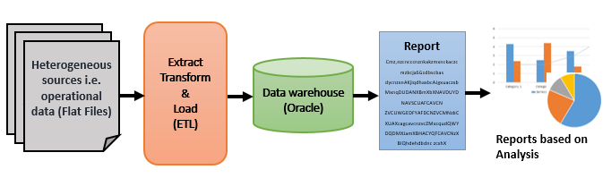

* 1. Schema Design:

The project follows Star Schema.

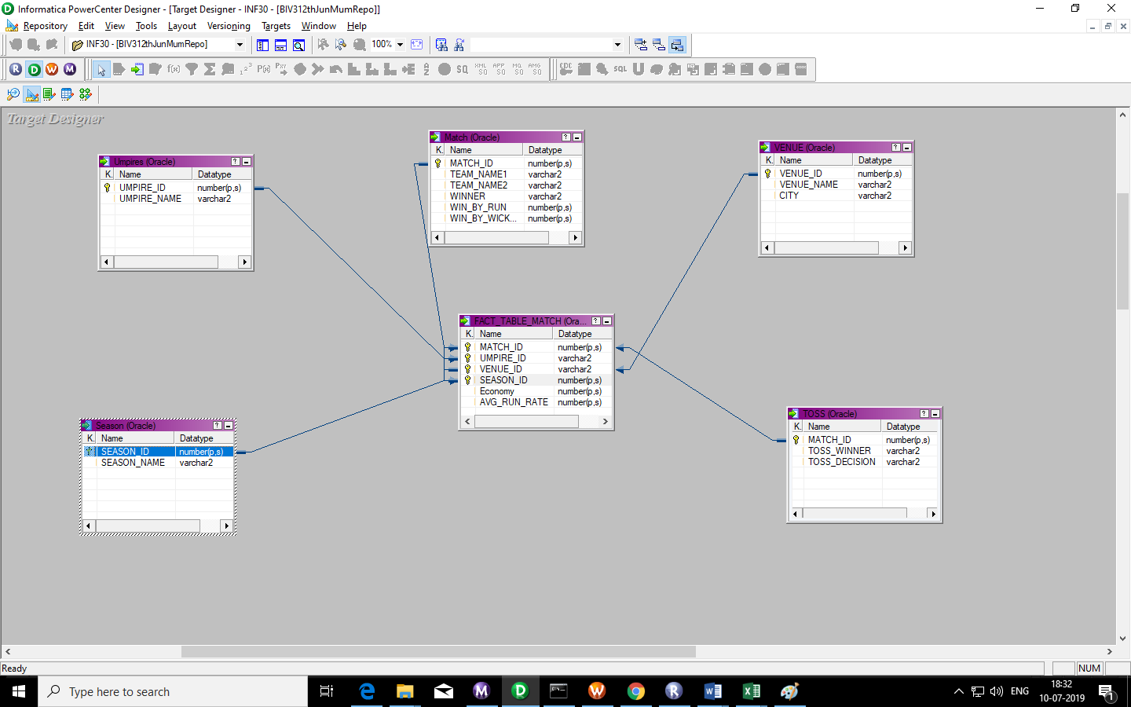

* FACT TABLE

1. Fact_table_match

This is a Fact table that contains the primary ids of all the matches, umpires, venues, seasons, along with the economy and average run rate.

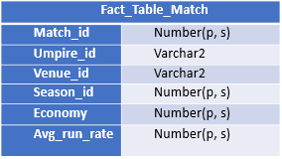

* DIMENSION TABLE

1. Umpires

This dimension table contains the Umpire_id as a primary key.

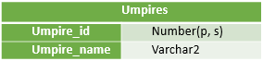

1. Match

This dimension table contains the Match_id as a primary key.

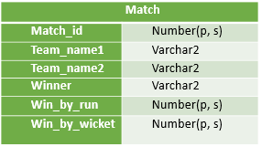

1. Venue

This dimension table contains the Venue_id as a primary key.

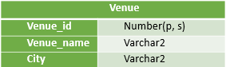

1. Season

This dimension table contains the Season_id as a primary key.

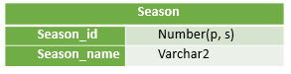

1. Toss

This dimension table contains the Match_id as a primary key.

